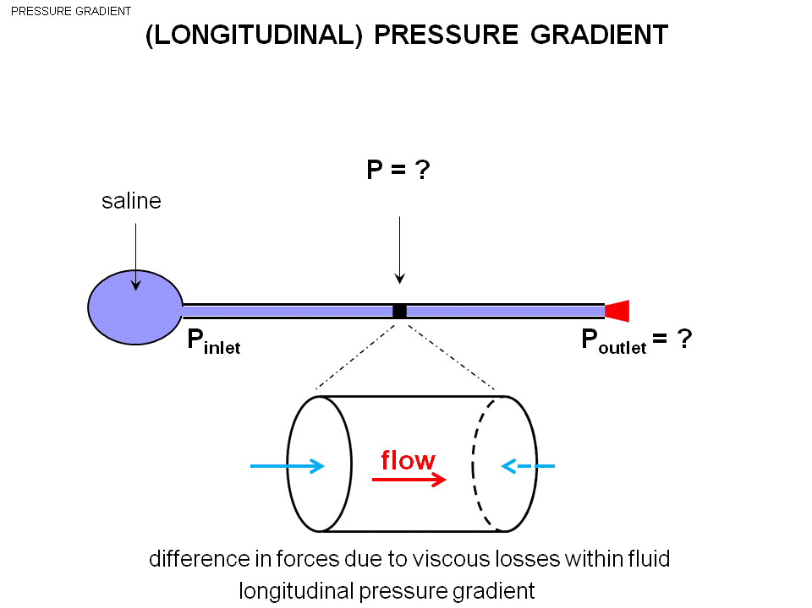

Pinlet anf Poutlet difference make up the flow.

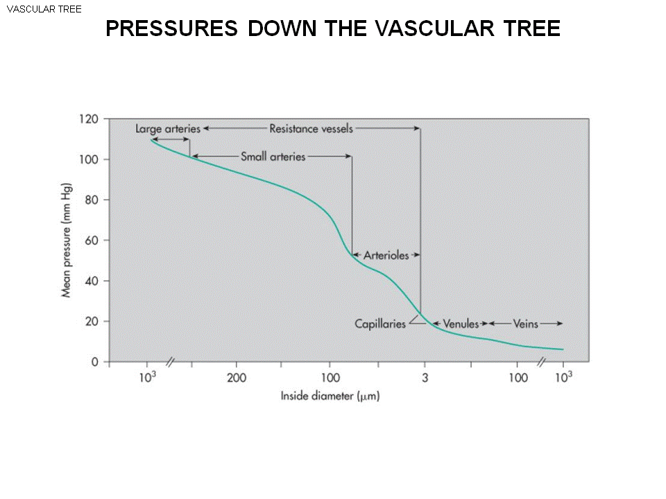
If there is a flow moving down , the pressure is falling as moving down. It start from Aorta than arteries (branches,) the pressure is falling.

- In aorta, large arteries the pressure is :100mmHg(memorize )
- Branches to smaller arteries
- Arterioles : only 40 mmHg .
- In capillaries: 20 mmHg
- Venules, bigger veinules, smaller veins and big veins , vena cava :5mmHg.(memorize)
- The pressure move down through the vascular tree.

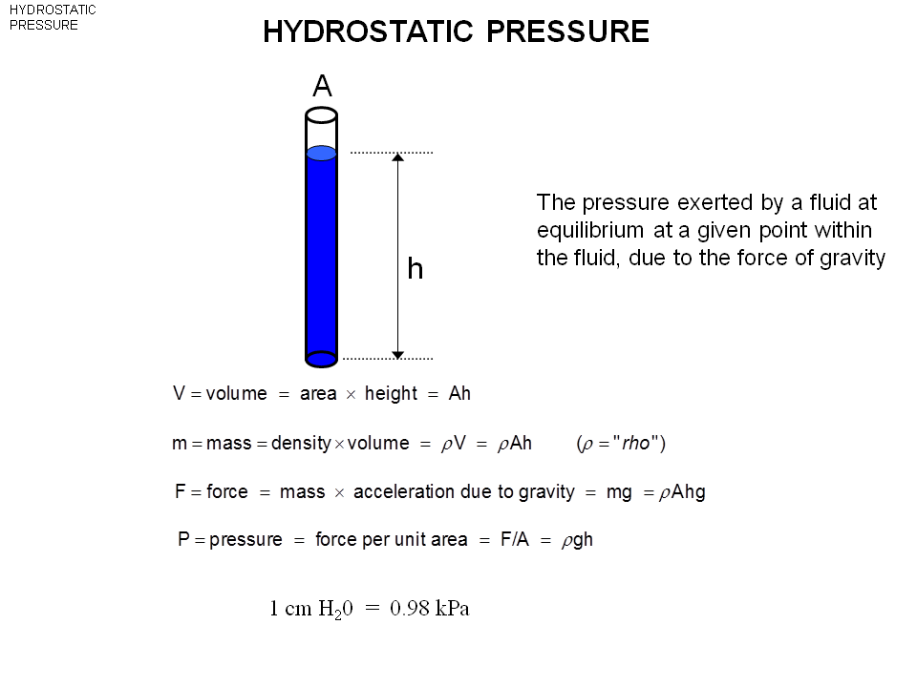
Hydrostatic pressure. － Hydro :water, static :standing: Hydrostatic pressure is the pressure you get in fluid when the pressure is not moving (unlike in previous the blood is moving around)
- The pressure exerted by fluid at equilibrium (means fluid is not moving) at a given point within the fluid due to the force of gravity when in space there is no hydrostatic pressure, cuz no gravity.
- A column of water in cylinder
- The surface (cross section) : A
- The height : h
- The pressure at the bottom : ?? (We want to know)
- If have a water on hand , where is the pressure source ? –the gravity (the weight of the object)
- step calculation:
- The volume of the fluid: A*h
- Mass : density *volume ( The column of mercury will be different from the column of H2o) (rho = density ) p*A*h
- The force existed = the weight :mass *gravity (g) = p*A*h *g This force is exerted over the area A.
- Divided the force by A. F/A ==p*g*h (this is the hydrostatic pressure exerted by the column height (h) to the A on the earth )
- A column of H20, 1 cm high The pressure is 1 cm H2o (we mean : the pressure here is the same as 1 cm H2O)
- Multiply the 3 numbers (p*g*h) = 980 Pa =0.98K Pa == 1 cmH2O ( just different unit )
- Assume we go to the top of fluid, the pressure is 0.
- Assume we go to the middle of the water (middle of the column): The pressure will be half.
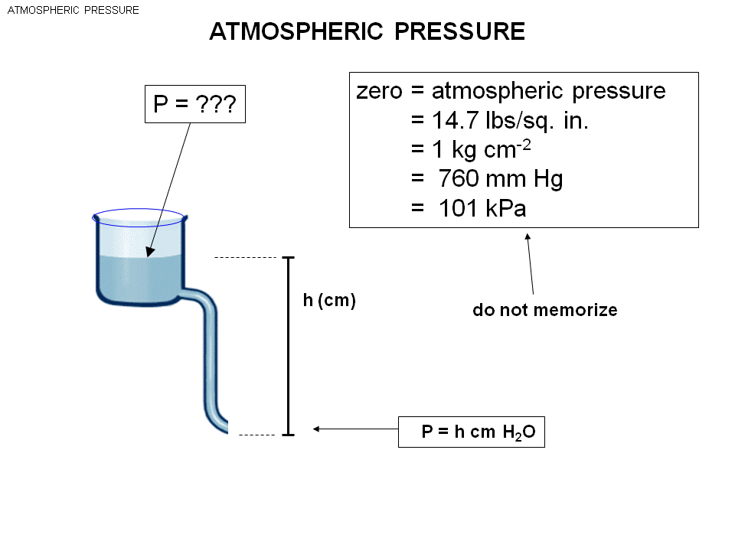
- The pressure is directly proportional to the height.

The cross section area is changing.
- The static pressure at the bottom is the pressure at the bottom. (IT DOESNT matter what happen in between the structure.)
- If H2o ==h cm H2o, if mercury == h cm mercury.
The air has a mass, density, weight and exert a pressure on the top of the fluid.
- At the top of the fluid, there is a weight of the air. This give a pressure to the fluid.
- This pressure is the same everywhere. Called Atmospheric pressure.
- In cardiovascular phgy: Atmospheric pressure is zero, due to everywhere in body there is atmospheric pressure and cancel out. (We focus on the difference in pressure only)
- Memorize : atmospheric pressure is 760mmHg.
PO2 in inspired air = 150 mmHg . PO2 in arterial blood is 100mmHg.
- 1/5 of the atmospheric air is oxygen .760 *1/5 = 150 mmHg
- Partial pressure means each element in air contribute a bit to the atmospheric pressure.
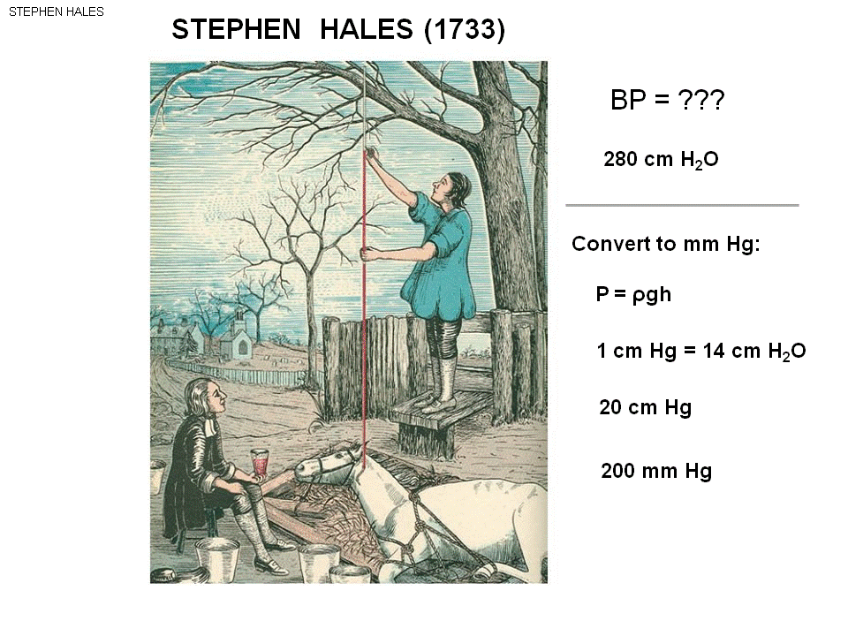

Use hydrostatic pressure to create an instrument to measure pressure.
The hydrostatic measurement to measure the blood pressure:
- They use a horse, insert a hollo glass tube into the horse artery.
- Human:The blood pressure in artery is 100mmHg, the pressure of tube is 0 .
- The pressure difference will start up the flow.
- The blood go into the tube and move up go to specific height, eventually stop moving. Why? - Now the gravity is equal.
- Ex: the 10cm blood create hydrostatic pressure = 10 cm H2o. (The density of blood is close to the density of blood )
- The pressure of the tube is pushing downward, and the pressure of horse blood is pushing upward. The blood wins in the begging, so filled in the tube, as the blood goes up to the tube and eventually stop flowing due to no net force (The height of hydrostatic blood pressure at the bottom of the tube ==the horse) ---the blood stop moving.
- The guy mark the blood height and found BP (in this case ) = 280 mmH20
- They measured 280 cmH20. the blood pressure of the horse.
- We often measure in mmHg.
- Want to convert to mmHg. (Hg is 14 times as dense as H20, so it will be less height)
- The column height will be 280*(1/14) = 20 mmHg.

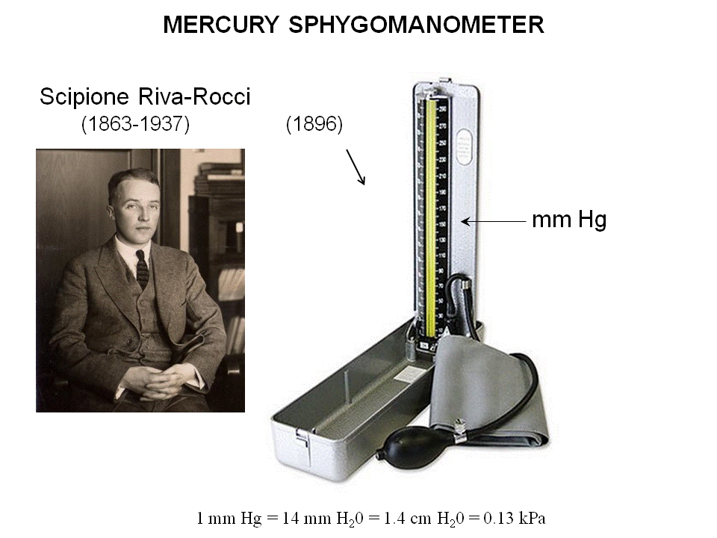
Mercury Sphygmo (pause) mano(pressure) meter – make a measure of arterial blood pressure.
-the column of mercury.
the pressure along the tube and the cuff is 50 mmHg, this mercury will move up until it reaches 50 mmHg.
- Now hydrostatic pressure == the cuff ==50 mmHg. Stop moving .

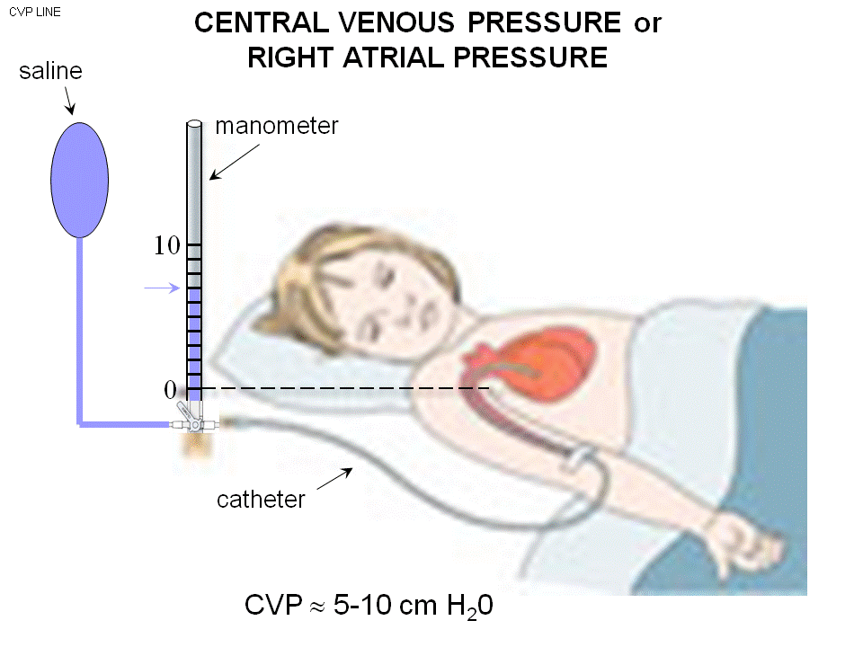

Central Venous pressure (Right Atrial Pressure)
- Put the catheter into the systematic vein, and keep pushing you enter right atrium (the picture here.) It will enter one of the two great veins (vena cava) which bring the blood the right atrium.
- If the catheter tip enter the right atrium , we call it the right atrium pressure.
- If enter the vein only , call it central venous pressure.
- The object is to record the pressure of the right atrium or the vena cava. (The two pressure is very close, vena cava have a higher pressure than the right atrium. ---the flow direction is from the vein to atrium. Flow go from high pressure to low pressure.)
- The bag is filled with saline, and the hollo glass tube (manometer in cm) is used to measure the pressure. The catheter is put into the patient to be either in the great vein or the right atrium.
- You fill the line with fluid (before put the catheter into the patient.)
- You turn the 栓to the second position, the fluid will flow in to the manometer . The fluid will go to the height which is the height of the picture. ---now the system is primed. The line (catheter), manometer, and the bag is full of fluid.
- Flick the 栓to the third position, the fluid will be able to move in two direction(in catheter or manometer.) The bag is now off. Only left the continuous line.
- Make sure the fluid in manometer in height (higher than expected right atrium pressure) The height should be higher than expected, if the right atrium is 10 cm H2O, Filled to 15. The pressure in the bottom of manometer is :15cmH2O.
- If the pressure is 10cmH2O in atrium, the fluid will flow out of manometer, drop down. It will stop at 10cm H2O. Flow stops.
The hydrostatic pressure concept is used here to measure the central venous pressure.
A normal CVP ==5~10cmH2O. (10 mmH2O ==1 mmHg, so this pressure is 10 times smaller than the artery. )

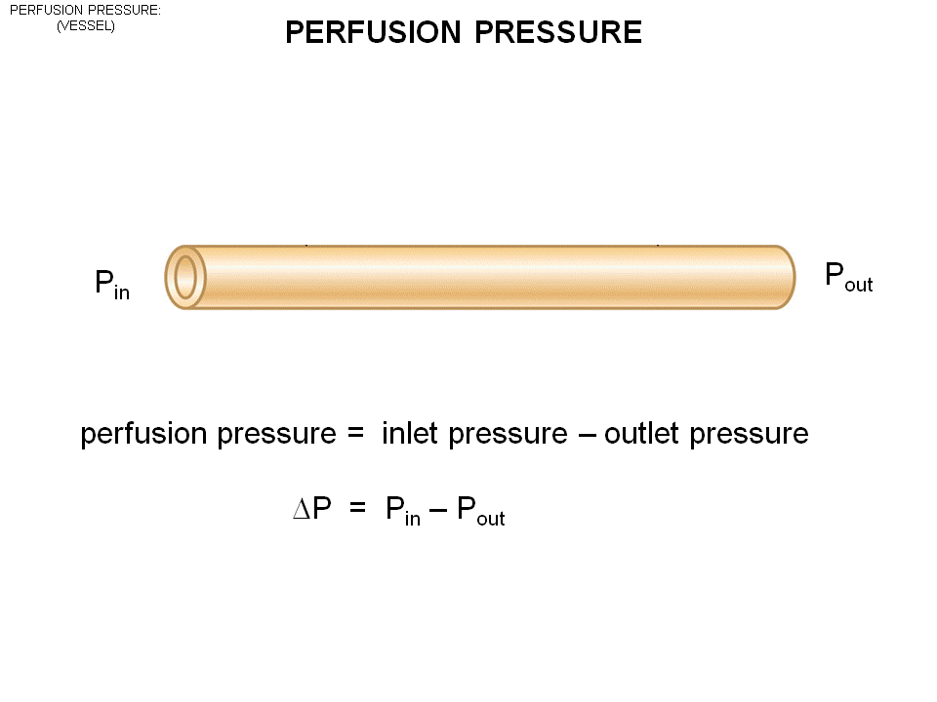
Perfusion pressure: inlet -outlet. (Pin- Pout)

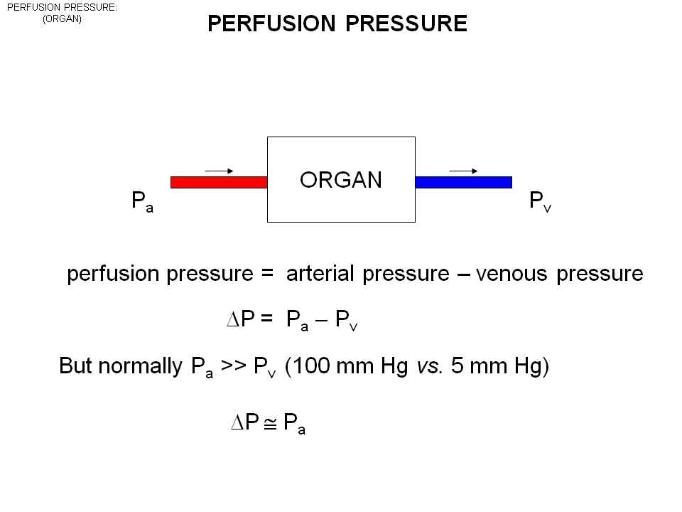

In the organ the inlet is arteria (bring blood to organ) l; the outlet is vein.

Arterial pressure – Venous pressure = perfusion pressure. This pressure is the one that force blood through the organs . If the perfusion pressure is 0, no flow.
- Pa ==100mmHg, Pv ==5mmHg, perfusion pressure is : 100-5 =95 mmHg. (close to 100 mmHg, so we said : Perfusion pressure is approximately arterial pressure)
Under abnormal circumstances, the venous pressure start to rise, can’t use this approximation. If Pv = 30 mmHg, P perfusion = 60 mmHg.
Under normal circumstances , arterial is much larger than venous. The arterial pressure approximate perfusion pressure . ( The arterial pressure is important because it control the perfusion pressure.)
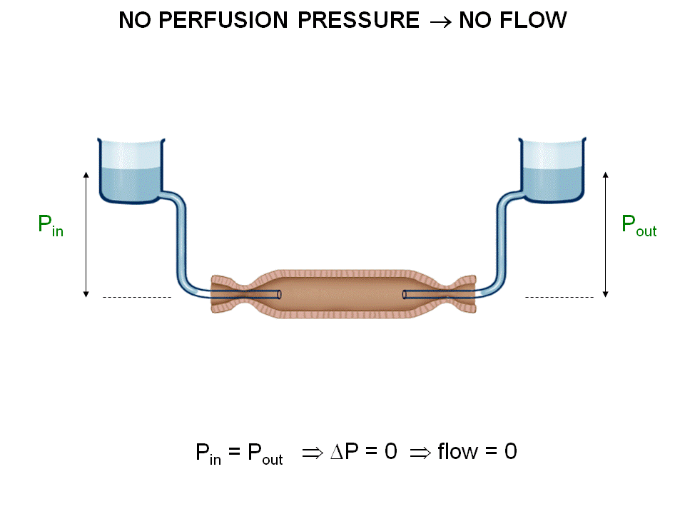

The brown color is the vessel.
The tube comes into the vessel, The height (ex: 10 cm ) give the pressure (P= 10 cm H2o.) Same on the other side.
- If the inlet pressure = outlet pressure , the flow? 0, because the perfusion pressure is 0.

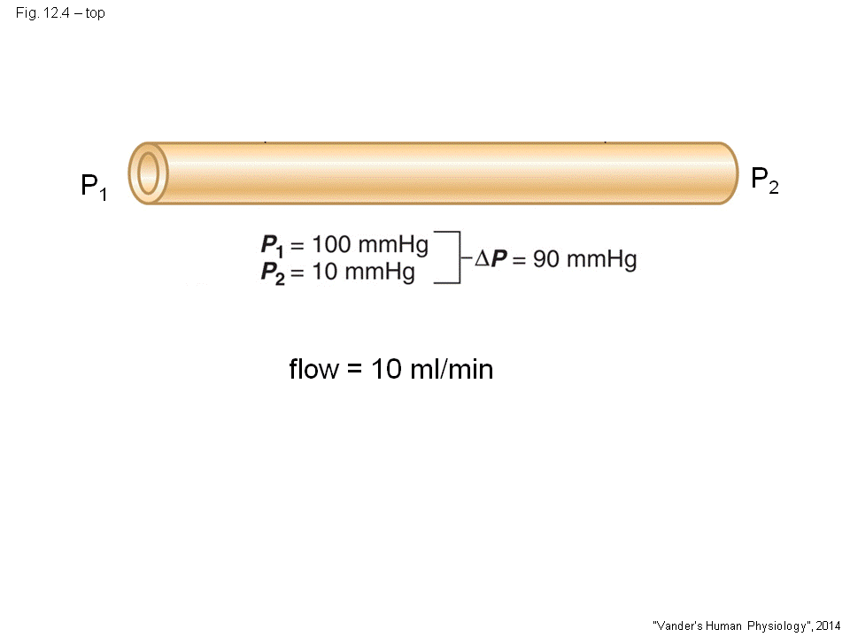
Assume the same vessel.
P1 =100mmHg, p2 = 10mmHg.
Perfusion pressure = 90.
Flow = 10ml/min.
Assume we raise the pressure 1 up to 400mmHg. P2 up to 400mmHg.
- P1 now = 500mmHg
- P2 now =410 mmHg.
- Perfusion pressure still 90 mmHg.
- The flow no change
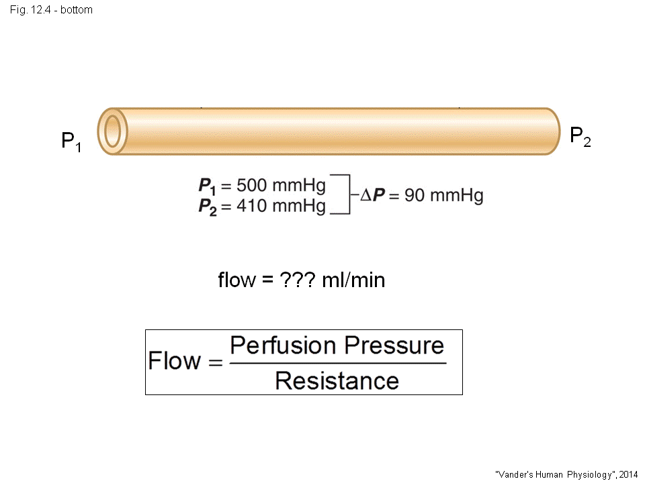
- You can have any pressure, as long as the perfusion pressure is unchanged, the flow is unchanged. ( This is also why we neglect atmospheric pressure )

The vessel only 2 things control the flow: perfusion Pressure and Resistance.
If double perfusion pressure , flow increase 2 times. If make it 10% , flow is only 10%.
Resistance is a funny quality.

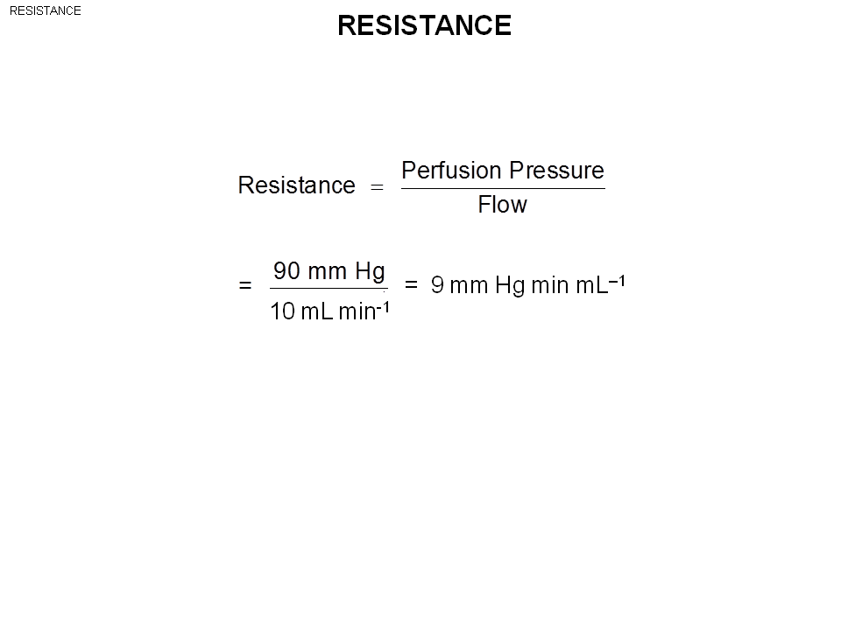
Resistance can’t be directly measured.
- We have to calculate the perfusion pressure, and measure the flow => calculate the pressure.
- Resistant = delta P/Flow
- Ex: 9 mmHg min ml-1 = 540 mmHg ml-1 sec ( This is the unit of resistant )

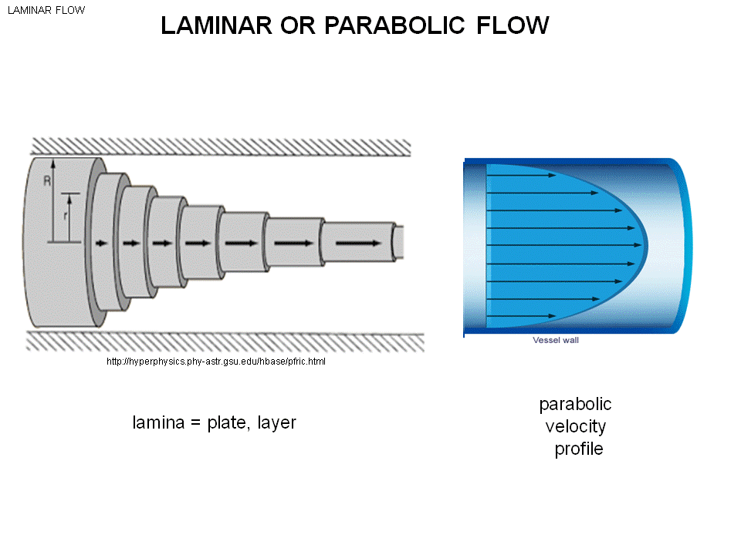
In many vessels , the flow is called laminar flow.
- The flow is like the left pic. So the flow close to artery is not moving at all. As get closer to the central of vessel, the blood move more quickly.
- The flow is A*V, this is only true when all the blood is moving by V. In this case, the flow is by the average of V *A. This is in reality infinite small layers sliding along each other. Laminar means layer in Latin word.
- Need to apply work to expand, the friction is in between each layer. They are robbing along each other, need to be continuously pulled along (gives u pressure gradient).
- Remember we said before, there is frictional losses when moving along, the internal fluid (viscosity) viscos fluid.
- Which fluid has a higher viscus to flow? Honey has a higher internal resistant than H2O.
- Called parabolic flow : If you look at the profile of velocity : close to the wall, v is small and move in the direction (to middle ) v gets bigger.
- If rotate 90 degrees, speed = x^2.
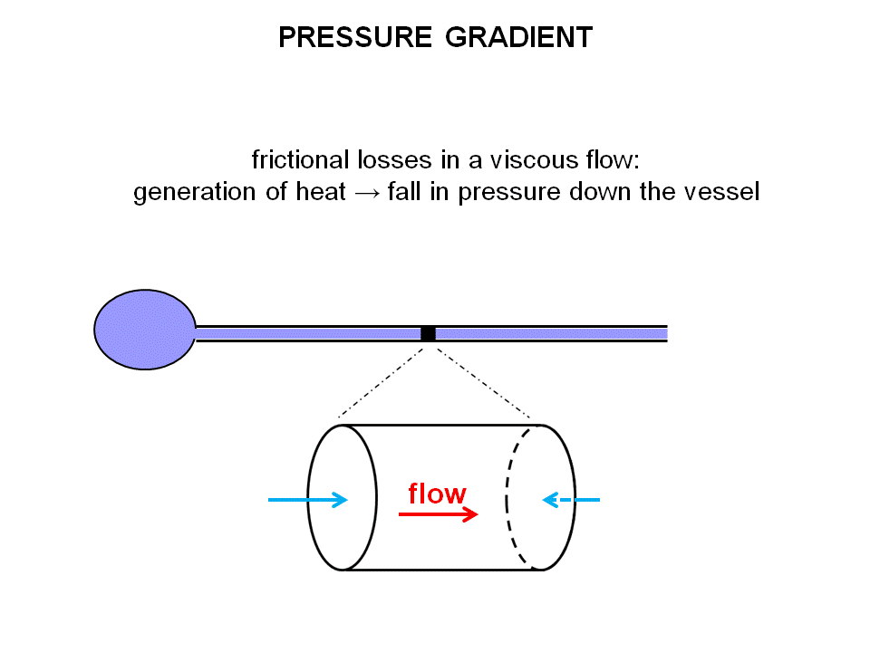
The frictional losses in a viscous flow , sliding over each other. Feel hot.
- When cold things down, some of the fluid become super fluid.
- As the fluid move along, generate heat , the heat is from the pressure energy . So as move down the tube the pressure drop. Because using the pressure to overcome internal friction , so the fluid keep at the constant speed.

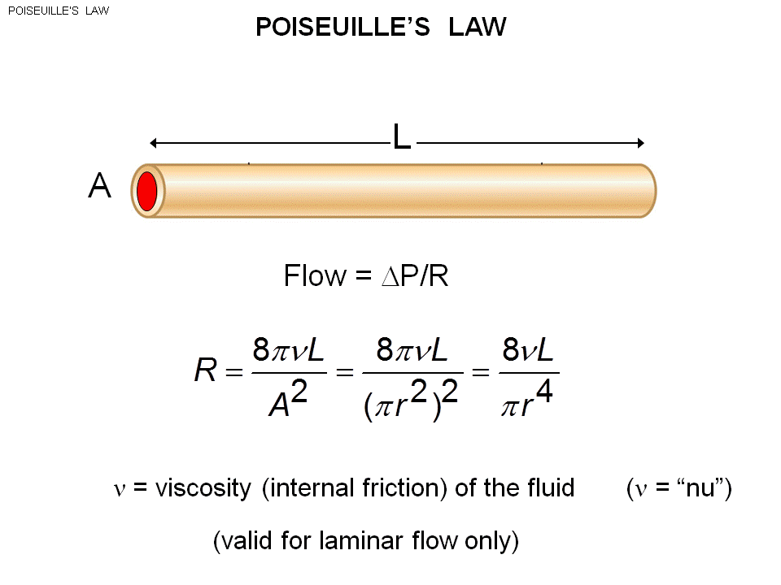

Poiseuille’s law: valid for laminar flow.
Vessel with length L.
The flow is delta P/R.
He figure out what is resistant.
- The resistant is given by the vessel property.
The resistant is 8L*v / pi*r^4 (no need to memorize )
- But know the resistant is directly proportional to velocity, length and inversely proportional to the radius of vessel.
- Generate pressure (ex: blow) – to the big and small tube. (The big tube give a larger flow.
- As the radius goes up, the resistant falls.
- When the resistance falls, the flow will increases.
- The resistant is directly proportion to the length/V inversely to the R. (must on exam)

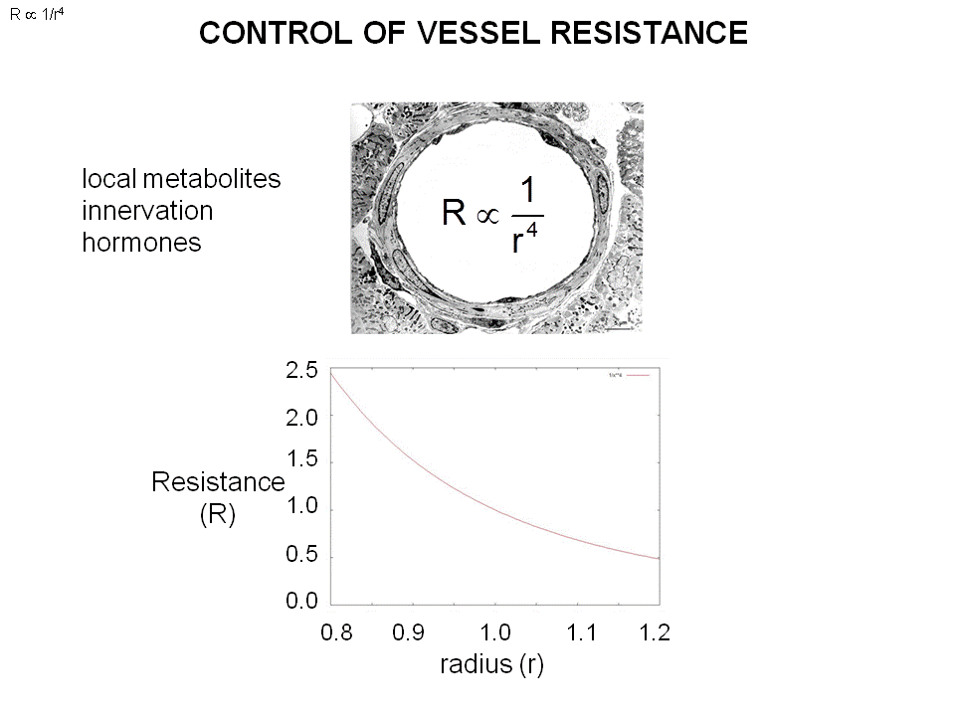
Under the same pressure, the larger radius smaller the resistance, the greater the flow .
- To control the blood pressure
- By squeezing the smooth muscle in arterials , change the radius (cross section)(You can’t change the length and velocity of the vessel) allow the resistance to be changed

